NATIONAL UNIVERSITY OF SCIENCES AND TECHNLOGY

(DEPARTMENT OF MECHANICAL AND MANUFACTURING ENGINEERING)

FOP LAB TASK

NAME: SYED ALI NAQI

SUBMITTED ON : 26-10-2023

CMS ID : 466889

**TASK 1**

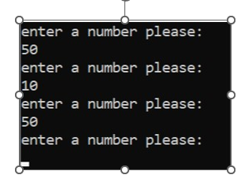int main() {

int x=1;

do {

cout<<"enter a number please: " << endl;

cin>>x;

}

while (x>0) ;

return 0;

}

**Task 2**

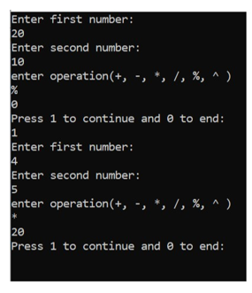int main() {

int num1, num2 , Ans=0 ,i;

char oper;

do {

cout<<"Enter first number: "<<endl;

cin>>num1;

cout<<"Enter second number: "<<endl;

cin>>num2;

cout<<"enter operation(+, -, *, /, %, ^ )"<<endl;

cin>>oper;

switch (oper) {

case '+':

Ans=num1+num2;

break;

case '-':

Ans=num1-num2;

break;

case '*':

Ans=num1*num2;

break;

case '/':

if (num1==0) {

cout<<"Invalid first number."<<endl;

}

Ans=num1/num2;

break;

case '%':

if (num2==0) {

cout<<"Invalid second number."<<endl;

}

Ans=num1%num2;

break;

case '^':

Ans=pow(num1,num2);

default:

cout<<"Invalid operation, please try again"<<endl;

}

cout<<Ans <<endl;

cout<<"Press 1 to continue and 0 to end: "<<endl;

cin>>i;

}

while (i==1);

return 0;

}

**TASK 3a**

int main() {

int num=2,Sum=0;

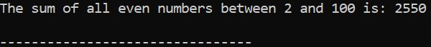while (num<=100) {

if (num%2==0) {

Sum =Sum+num;

}

num++;

}

cout<<"The sum of all even numbers between 2 and 100 is: "<<Sum<<endl;

return 0;

}

**TASK 3b**

int main() {

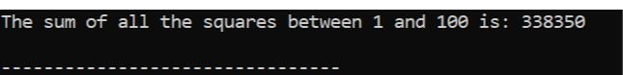int y=1,total=0;

while (y<=100) {

total=total + y*y;

y++;

}

cout<<"The sum of all the squares between 1 and 100 is: "<<total<<endl;

return 0;

}

**TASK 4a**

int main() {

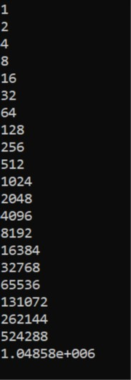int var=0;

while (var<=20) {

cout<<pow(2,var)<<endl;

+;

}

return 0;

}

**TASK 4b**

int main() {

int a1,b1;

int Total=0;

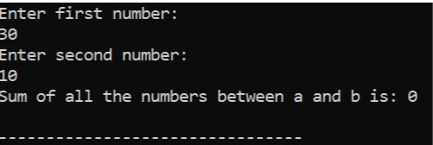cout<<"Enter first number: "<<endl;

cin>>a1;

cout<<"Enter second number: "<<endl;

cin>>b1;

while (a1<=b1) {

if (a1%2==1 ) {

Total=Total+a1;

}

a1++;

}

cout<<"Sum of all the numbers between a and b is: "<<Total<<endl;}